Procedure to follow to while integrating JIRA with Jenkins

**Abstract**

This document provides the steps to configure JIRA with Jenkins for Issue Tracking within a pipeline project.

The document provides scripts to create an issue, assign an issue to someone, comment on an issue and Transit an issue to another state.

Table of Contents

Prerequisites 4

Creating an issue in Jira 5

Adding Comment and transit an issue to another state 6

# Prerequisites

* **Creating Jira Project**

Before beginning with the procedure you need have an Atlassian account with JIRA software (You can get free one week trail account). On this account create a project with relevant name. To do so…

Go to **JIRA software 🡪 Projects 🡪 Create project 🡪 Classic Project**

And fill out all necessary data required to create the project.

* **Configuring JIRA plugin in Jenkins**

Install the following plugins in your Jenkins

* + JIRA plugin
  + JIRA Pipeline Steps
  + Jira Integration for Jenkins

To configure the JIRA settings in your Jenkins

Go to **Manage Jenkins 🡪 Configure System 🡪JIRA Steps**

And provide necessary information

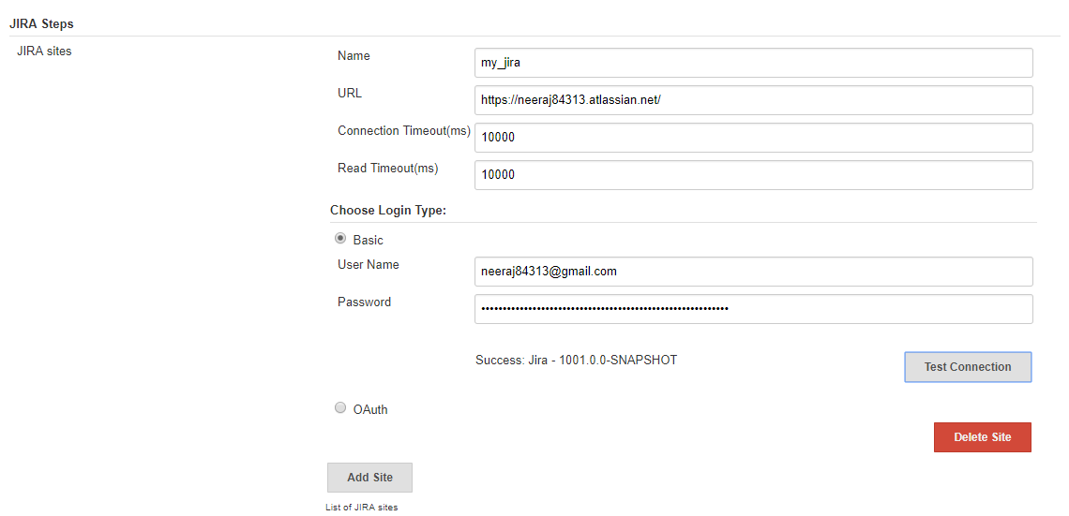

# Creating an issue in Jira

Depending upon the use cases and type of pipeline script you can write the following scripts inside try/catch blocks, or as a stage in a pipeline or as post build steps.

Script for creating an issue and assigning it to someone.

withEnv(['JIRA_SITE=<Local JIRA name>']) {

def testIssue = [fields: [ project: [key: '<Project key>'],

summary: 'Build Fail',

description: 'Build has failed for application.',

issuetype: [name: 'Bug']]]

response = jiraNewIssue issue: testIssue

echo response.successful.toString()

echo response.data.toString()

jiraAssignIssue idOrKey: <issue ID> userName: '<assignee>'

}

# Adding Comment and transit an issue to another state

You can add comments to any jira ticket at any point of your pipeline depending upon the use case of your project. To transit an issue to a state you need to get the **transition ID** of that state. To find all transition ids of your project

Go to **JIRA 🡪 Project settings 🡪 Workflows 🡪 Edit workflow**

You must get something like this

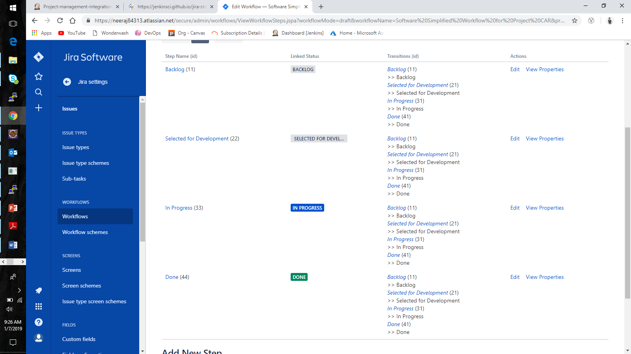

If you notice you can see transition ids written besides all possible transitions.

With this information in hand you are now ready to perform required operations on a JIRA ticket.

* **Script to add comment**

withEnv(['JIRA_SITE=<Local JIRA name>']) {

jiraAddComment idOrKey:<Issue ID>, comment: '<comment>'

**}**

* **Script to transit an issue**

withEnv(['JIRA_SITE=<Local JIRA name>']) {

def transitionInput =

[

transition: [

id: '<Transition ID>'

]

]

jiraTransitionIssue idOrKey:<Issue ID>, input: transitionInput

}